Course code :CSA1366 TOC

EXP NO: 1 reg no: 192121156l

Name:p.gokulnath

DETERMINISTIC FINITE AUTOMATA (DFA)

AIM:

To write a C program to simulate a Deterministic Finite Automata.

ALGORTIHM:

1. Draw a DFA for the given language and construct the transition table.

2. Store the transition table in a two-dimensional array.

3. Initialize present state, next state, and final state

4. Get the input string from the user.

5. Find the length of the input string.

6. Read the input string character by character.

7. Repeat step 8 for every character 8.

Refer the transition table for the entry corresponding to the present state and the current input symbol and update the next state.

9. When we reach the end of the input, if the final state is reached, the input is accepted. Otherwise, the input is not accepted.

Program:

#include<stdio.h>

#include<string.h>

#define max 20

int main()

{

int trans_table[4][2]={{1,3},{1,2},{1,2},{3,3}};

int final_state=2,i;

int present_state=0;

int next_state=0;

int invalid=0;

char input_string[max];

printf("Enter a string:");

scanf("%s",input_string);

int l=strlen(input_string);

for(i=0;i<l;i++)

{

if(input_string[i]=='a')

next_state=trans_table[present_state][0];

else if(input_string[i]=='b')

next_state=trans_table[present_state][1];

else

invalid=l;

present_state=next_state;

}

if(invalid==l)

{

printf("Invalid input");

}

else if(present_state==final_state)

printf("Accept\n");

else

printf("Don't Accept\n");

}

Output:

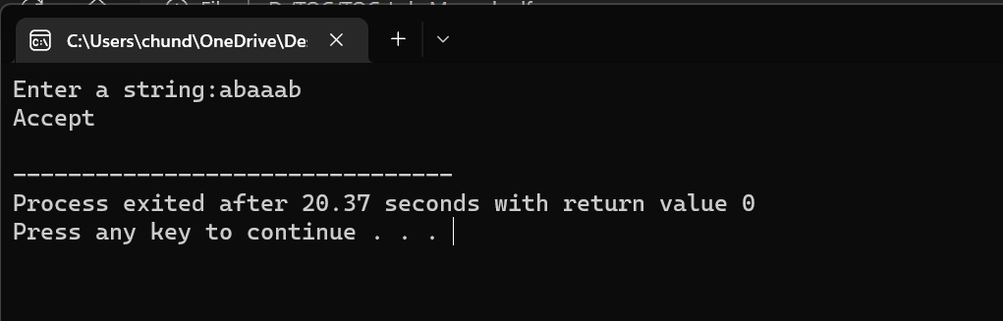

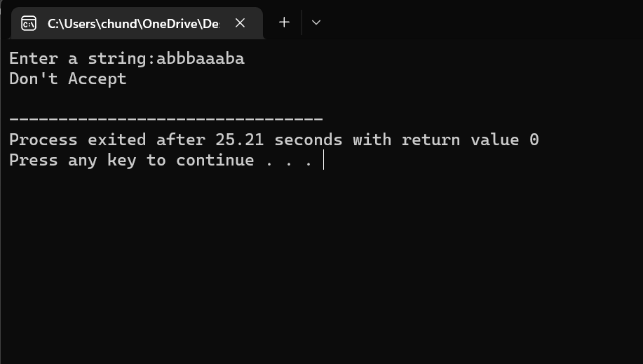

Result: therefore we can succussfully sitmulate a DFA using c program